Article title: In this section, the article title should be written in Nazanin font (bold) with size 14.
Authors of the article: In this section, the full name of authors should be written in Nazanin font (bold), (size 13)
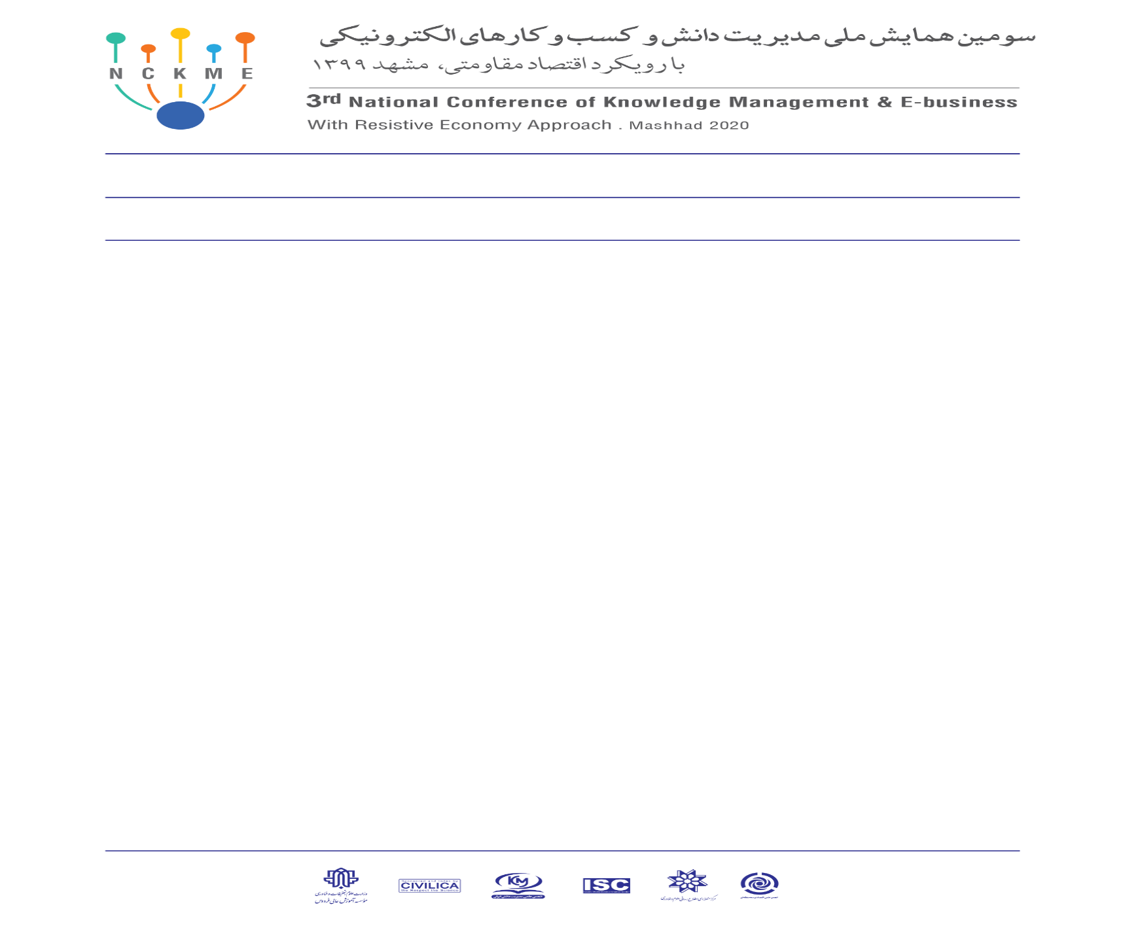
Abstract: In this part, the abstract of the article should be written in 300 words with regular Nazanin font (size 12).

